
Hearty congratulations to BRENDA K., winner of Christians Read’s mega-contest.
LOVE IS MURDER makes the USA Today Bestseller List. Sandra Brown, who edited the collection of short stories, said something terrific about my WED TO DEATH: As a long-time admirer of Sandra’s, I can’t say which of these two events thrilled me more.
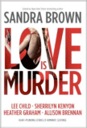
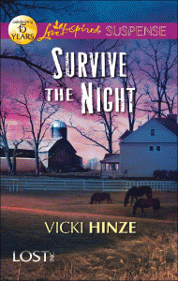
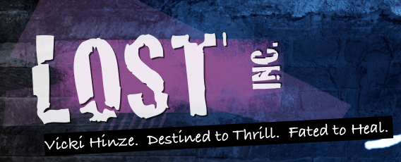
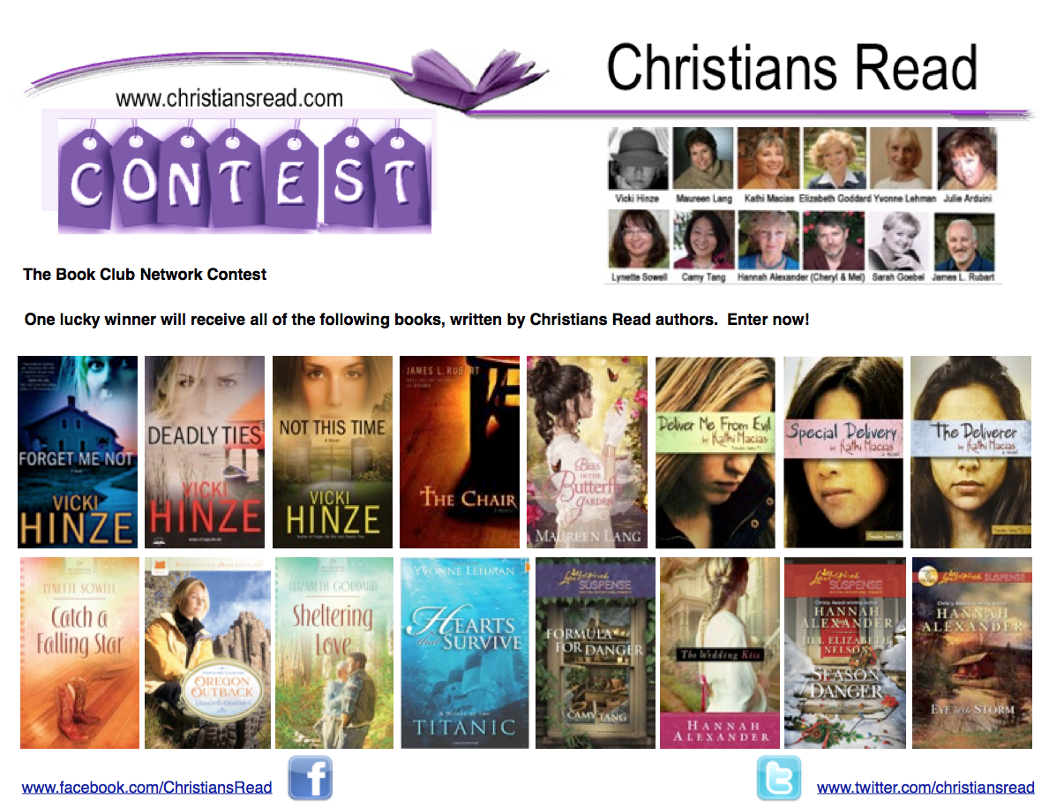
For those not aware, Christians Read is one of my special projects. It’s a place where authors and readers come together to discuss books, life, everyday issues. You’re welcome to join us at: www.christiansread.com.
July 2012
Greetings!

Summer is supposed to be a time of picnics and beach trips--the lazy time of the year. But that’s just not happened for many of us across the nation. From floods in Florida to fires in Colorado to heat waves that have the rest of us sweltering, vacations and fun times have been relegated to the back burner. My thoughts and prayers are with those impacted by all these events.

We took a day trip to the Pensacola Naval Aviation Museum with our daughter and the grands--love that museum--and were parked to pick up Georgia peaches at a produce stand when we got rammed by a truck. No injuries, but my back is really not happy. Spasms for a week. That aside, I’m mourning the end of baseball season. You know how much I love the games.

Lots of book news to share, which is always fun! All that’s below. I sure hope you and yours are having a terrific summer!

Blessings, Vicki
BOOK
NEWS
LOST, INC., my new mini-series for Love Inspired Suspense, is all set to start in October. The first title, SURVIVE THE NIGHT, is now preordering and I have the cover! I love it.

The next two books are CHRISTMAS COUNTDOWN (Dec) and TORN LOYALTIES (Feb). I hope you’ll enjoy this new series as much as I am enjoying it. These are Christian Romantic Suspense novels. You can learn more at the Lost, Inc. website: www.lost-inc.com.

If you want to preorder now, see the buttons below or check with your favorite bookseller. I’ll post the Readers’ Group Guide & 1st chapter in a bit.
PREORDERING NOW
“Hinze has penned a heart-stopping story about true commitment. You may need a hanky.” – Sandra Brown
You’ve been asking what happened to SHADES OF GRAY, which was to be reissued in April. Well, we delayed it due to those other books that have been topping the charts. The publisher and I were concerned that there’d be confusion and neither of us want that. It’s ready to go and will be out when we think the environment is less apt to create challenges. But--a surprise for you--here’s the new cover. Her face is a mosaic and I LOVE this cover! It’s not up on the website yet, but I wanted you to have a sneak peek.

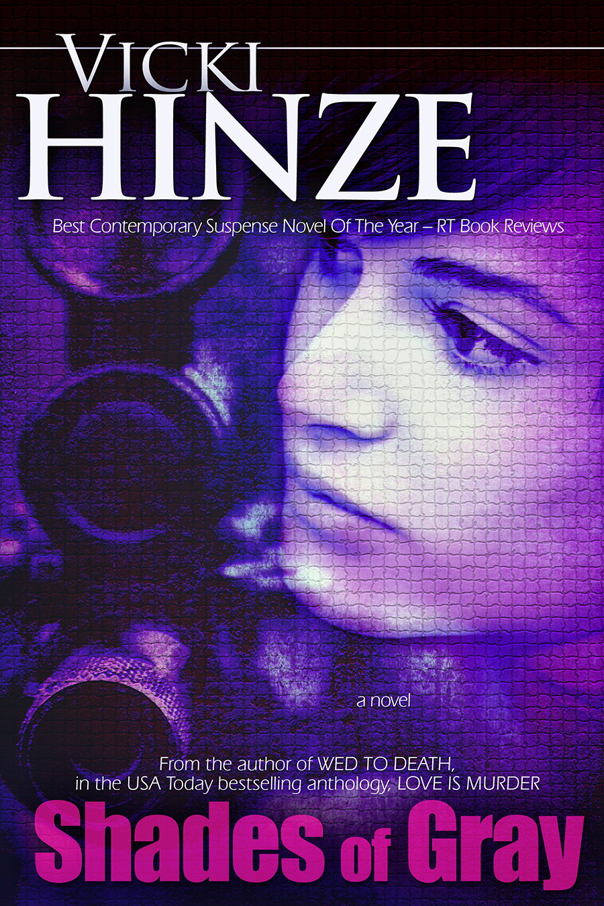
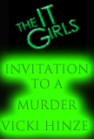




I’ve been getting a lot of email about INVITATION TO A MURDER, the prequel to the IT GIRLS series. If you’ll recall, I wrote the prequel and the last book, BULLETPROOF PRINCESS in the series and Twin Stars Entertainment optioned it for film. Well, ITAM is available only as an online read and always has been. Since so many of you wrote about it, I contacted Harlequin and they have it online now. I’m not sure how long it will be there, but if you’d like to read it, now is the time. And the best news? It’s FREE! You can read Invitation to a Murder at:http://www.harlequin.com/articlepage.html?articleId=1104&chapter=1 Again, I have no idea how long it’ll be there, so don’t linger!
ON THE WRITING FRONT

After finishing TORN LOYALTIES, I wanted a change of pace, so I’m working on a heartwarming holiday story. More news on it next month.

That aside, I’ve taken a break from political posts--my blood pressure needed the rest. :) I’ve also been asked to write a monthly column and some feature articles for a print magazine and I’m very much looking forward to that. I’ll share more news on it as I can, but I do believe you’re going to be as excited about it as I am.

Because of writing commitments, I’ve had to blog a bit less and I miss it. So I’m looking forward to things calming down and getting back on schedule with it. (Thanks too for your posts asking about that! It touches my heart to hear that these posts mean so much to you.)

I have posted some video blogs on the youtube channel, Facebook author page, and on Pinterest. Writers--anyone needing a little inspiration--might find those interesting. And on Pinterest, there are all kinds of boards--books and writing related and not. I’m totally enjoying that site.

Until next time, be well and safe and joyful. Know that I’m wishing you and yours many

Blessings,

Vicki

